Page No. | Article and author(s) | Graphical abstracts
60 | Investigation on the bioactive metal complexes containing ferrocenyl β-diketone ligand  Md. Nur Amin Bitu, Md. Ali Asraf, Md. Faruk Hossen, C. M. Zakaria, and Md. Kudrat-E-Zahan | Synthesis of Cd(II), Zr(IV), U(IV), Co(II), Ni(II), Zn(II) and Cu(II) ion complexes containing ferrocenyl β-diketone ligand is reported. | 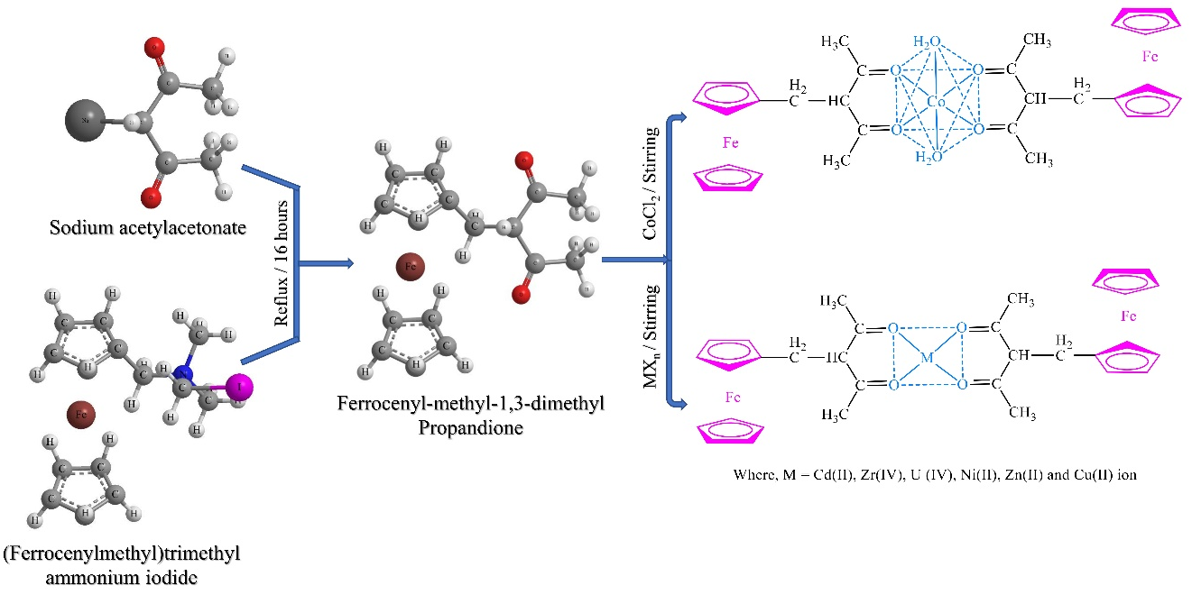
93 | Kinetic investigation on the reduction of colloidal manganese dioxide by formic acid in different micellar systems  Jamil Ahmed, M. Muhibur Rahman, M. Yousuf A. Mollah, and Md. Abu Bin Hasan Susan | Kinetics of the reduction of colloidal manganese dioxide by formic acid was studied both in the absence and in presence of micellar systems of an anionic (sodium dodecyl sulfate, SDS), a cationic (cetyltrimethyl-ammonium bromide, CTAB) and a non-ionic surfactant (Triton X-100, TX-100) in aqueous solution. |  |  | 